Student expense TRACK DATABASE management system

IST659 Project Design Report

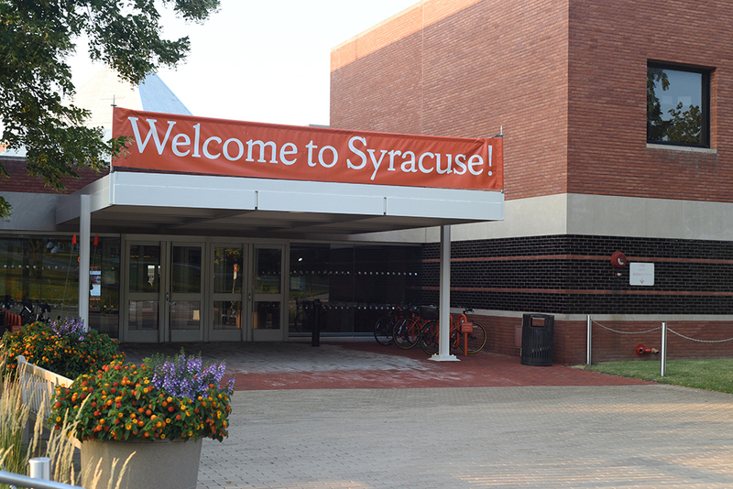

Aditya Kini

Rajvee Shah

**Project Summary**

Syracuse University is a private institution which consists of diverse students enrolled from all over the world. The university has a number of on campus stores wherein the students can purchase various commodities like books, clothing, grocery, electronics and other stuff which are required for educational purposes. One of the types of stores of paramount importance to a student’s academics are the bookstores.

The university has two bookstores, one at the Schine Center and another one at Slocum center. The name ‘bookstore’ is actually a misleading name for these stores, because they typically are a hub for everything that you require to get comfortable in your new home away from home. The bookstore has products ranging from hoodies and t-shirts to sweats, personal care to general mart items, electronics to stationary and a lot more. With such a plethora of stocked items, it gets a heavy footfall at any point of the day, which means a lot of purchase history is recorded in the bookstore database.

The bookstore is a repository of all the purchases of each student. Whenever a student makes a purchase and swipes his/her SUID, after getting categorized as a student, it is automatically added to his/her database history. Currently, the bookstore uses the SUID, transaction ID and the price of the product to store information pertaining to a student.

There isn’t any system which enables students to remotely keep a track of their bookstore purchases. The student is not availed of such a facility. This becomes a hassle for the student who makes a purchase at the bookstore, sometimes unaware that the very item he/she is purchasing has already been purchased in the near past.

Here, we are going to build and implement a central system, from the student’s perspective, where the student can keep track of all his/her expenses made during the particular academic year. The database will primarily constitute of the first and last names of students, their SUID, prices of products at every purchase and respective dates and the total expenditure till that point of time. This system will help the student to avoid the redundancy of buying the same product in the future.

The students will be able to access their expenses by logging into the system with the help of their SU credentials. The portal can be an online platform, somewhat similar to the one we use for our assignments. This will be very helpful to the students in terms of managing their expenses at the bookstore and would give them all the information they need on a single database. It would be as easy as the click of a button.

**Entities and Attributes**

**STUDENT ENTITY:**

|  |  |
| --- | --- |
| **Attributes** | **Description** |
| SUID | Primary key |
| SFirst name | Describes the first name of the student |
| SLast Name | Describes the last name of the student |
| SEmail Address | Identifies the email address of the student |
| Degree | Indicates the student’s course level |
| Major | Describes the program which the student is pursuing |

**PARENT ENTITY:**

|  |  |
| --- | --- |
| **Attributes** | **Description** |
| Parent ID | Primary key |
| PFirst Name | Describes the first name of the parent |
| PLast Name | Describes the last name of the parent |

**PURCHASE ENTITY:**

|  |  |
| --- | --- |
| **Attributes** | **Description** |
| Purchase ID | Primary key |
| Purchase Date | Mentions the date the purchase was made |
| Payment Method | Describes the method of payment |
| SUID | Foreign key |

**PAYMENT METHOD:**

|  |  |
| --- | --- |
| **Attributes** | **Description** |
| MethodID | Primary Key |
| Methodname | Identifies the bookstore from where the purchase was made |

**BOOKSTORE ENTITY:**

|  |  |
| --- | --- |
| **Attributes** | **Description** |
| Bookstore ID | Primary Key |
| Bookstore Name | Gives the name of the bookstore |

**PRODUCT ENTITY:**

|  |  |
| --- | --- |
| **Attributes** | **Description** |
| ProductID | Primary Key |
| ProductName | Gives the name of the product |

**BOOKSTOREPRODUCTS ENTITY:**

|  |  |
| --- | --- |
| **Attributes** | **Description** |
| Bookstore ID | Composite Primary Key |
| Product ID | Composite Primary Key |
| Stock Quantity | Gives the quantity of products in Stock |

**PURCHASEITEMS ENTITY:**

|  |  |
| --- | --- |
| **Attributes** | **Description** |
| Bookstore ID | Composite Primary Key |
| Product ID | Composite Primary Key |
| Purchase ID | Composite Primary Key |
| SUID | Composite Primary Key |
| Quantity | Gives the quantity of products |

**Relational Data Model**



**Business Rules**

1.     Purchaser should be a student of Syracuse University.

2.     He/she must have a valid SUID.

3.     Purchase should only be made in the SU Bookstore.

4.     Must have a minimum transaction of $5 every time.

5.     Purchases must be made during the semester.

6.     Mode of payment should be only cash or card.

7. Student can have one or two parents, every parent can be related to just one student.

**Major Data Questions**

1. How many times does an average student shop at the bookstore in a month?
2. Which mode of payment is used more extensively?
3. What about the data of purchases made before or after the end of a semester?
4. Do parents and students have equal access to the system?
5. Till which date can student access the purchase history?